3.Scenario: You are working on a project that involves analyzing a dataset containing information about houses in a neighborhood. The dataset is stored in a CSV file, and you have imported it into a NumPy array named house_data. Each row of the array represents a house, and the columns contain various features such as the number of bedrooms, square footage, and sale price.

Question: Using NumPy arrays and operations, how would you find the average sale price of houses with more than four bedrooms in the neighborhood?

Code:

import numpy as np

import pandas as pd

try:

df = pd.read_csv(r"C:\Users\jampa\OneDrive\文档\house_data.csv")

house_data = df.to_numpy()

houses_more_than_4_bedrooms = house_data[house_data[:, 0] > 4]

if houses_more_than_4_bedrooms.size > 0:

sale_prices = houses_more_than_4_bedrooms[:, -1]

average_sale_price = np.mean(sale_prices)

print(f"Average sale price of houses with more than 4 bedrooms: ${average_sale_price:,.2f}")

else:

print("No houses with more than 4 bedrooms found.")

except FileNotFoundError:

print("Error: The file was not found. Please check the file path.")

except Exception as e:

print(f"An error occurred: {str(e)}")

output:

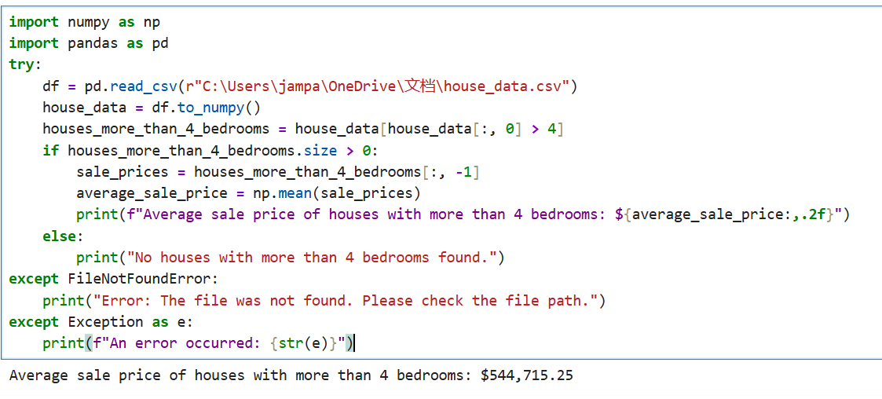

Dataset:

|  |  |  |  |
| --- | --- | --- | --- |
| Bedrooms | SquareFootage | SalePrice |  |
| 6 | 1704 | 950950 |  |
| 3 | 2822 | 828851 |  |
| 5 | 1892 | 889948 |  |
| 5 | 2256 | 127692 |  |
| 6 | 2719 | 210271 |  |
| 3 | 1191 | 464344 |  |
| 2 | 3788 | 330552 |  |
| 3 | 1899 | 669527 |  |
| 4 | 3671 | 230160 |  |
| 4 | 3098 | 989595 |  |
|  |  |  |  |